**Experiment No:7**

**Practice Queries using ANY, ALL, IN, EXISTS, UNION, INTERSECT Set Operators**

**Query:**

#Any

select BCOLOR from boats

where BID = ANY (select BID from reserves where day='2018-01-27');

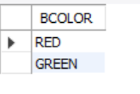

#All

select all BNAME from boats where true;

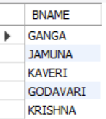

#Exists

select BNAME from boats

where Exists

(select RATING from sailors where sailors.SID = boats.BID and RATING >= 8);

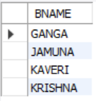

#in

select * from boats

where BCOLOR in ('PINK' , 'BLUE');

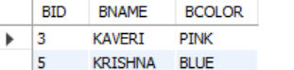

#union

select BNAME from boats union select SNAME from sailors;

